Overview
A Code Green is activated when an organized withdrawal or relocation of persons from an area at risk to a safe location is required. The decision to evacuate is always made by a thorough evaluation of the risks to client/resident care.

As in all emergencies, consider your safety first.

Definitions
Crisis Evacuation | - Unexpected and immediate threat to life and/or safety and there is not enough time to plan for the evacuation  - The decision to activate a crisis evacuation is made by the In-Charge staff member in the area at the time of the crisis  - Anyone, however, can remove someone from immediate danger
Precautionary Evacuation | - A credible, potential threat to life and/or safety and there is time to plan for the event  - The decision to perform a precautionary evacuation is made by the [Manager/Director of Care/Designate]. This decision may be made in consultation with Police, Ambulance and Fire Departments.
Horizontal Evacuation | - Move horizontally to a safe location on the same level
Vertical Evacuation | - Move vertically towards the ground floor
External Evacuation | - Move to another building/facility

Response Procedures

Crisis or Precautionary Evacuation
Crisis Evacuation Authorization: In-Charge Staff Member activates Code Green in a crisis situation
- Designate a runner/designate someone to announce overhead three times:
  - “Code Green [exact location – building, floor, room]”

Precautionary Evacuation Authorization: The [Manager/Director of Care/Designate] activates Code Green in a precautionary evacuation situation
- Designate a runner/designate someone to announce overhead three times:
  - “Code Green [exact location – building, floor, room]”

All Staff
- Listen to the overhead announcements or designated runner for further directions
- Return to your work area via safe route
- Reassure residents/clients and visitors and ask them to remain where they are until instructed to move or until the “All Clear” is announced
- Be prepared to assist with the evacuation and/or receive residents/clients in your work area

[Manager/Director of Care/Designate]
- Assume primary responsibility for directing/coordinating activities of the Code Green response
- In consultation with appropriate stakeholders, determine a safe area in the facility to relocate to or a staging area outside of the building for an external evacuation
- Notify:
  - [Insert departments/agencies/organizations to be notified and consider if family notifications should be made]
- Notify and/or request assistance from the following, as needed:
  - BC Emergency Health Services
  - Police
  - Fire Department
- Establish an Emergency Operations Centre (EOC)
- Assume or delegate the EOC Director role who is responsible for directing/coordinating activities of evacuation
- Assign EOC personnel and functions, as needed
- When appropriate, designate a runner/designate someone to announce overhead three times:
  - “Code Green – All Clear”

Affected Areas

[Nurse in-Charge/Manager/Director of Care/Designate]
- Refer to your unit’s Code Green Unit/Department plan, if applicable
- Notify additional leadership, as necessary
- In consultation with appropriate stakeholders, identify area of refuge (safe location), ensuring route and location have been checked for possible hazards
- Designate a runner/designate someone to announce overhead three times:
  - “Code Green [exact location – building, floor, room]”
- Determine the mobility and equipment needs of clients/residents
- Move clients/residents in the following order:
  - 1 – Persons most at risk
  - 2 – Persons easiest to move
  - 3 – Persons most difficult to move
- Conduct a census of all people to be evacuated using:
  - In-time census report of all clients/residents on unit or print client/resident schedule for the day
  - Staff and volunteer sign-in sheets/schedules
- Request assistance as needed/able
- Collect client/resident records, medications, equipment, etc. as able
- Collect any client/resident valuables, as able
- Collect administrative supply needs for unit (for example: narcotics keys, important documents etc.), as able
- Power down/cover any sensitive equipment to prevent damage, if time allows and its safe to do so
- Check all areas to ensure everyone is evacuated
- Mark the door to indicate rooms are evacuated as time allows (for example: evacu-tag, post-it notes, pillow on the floor, etc.)
- Leave lights on
- Upon arrival at safe location
  - Conduct a census of all evacuated people
  - Report status of your area to the EOC
  - Remain in assembly area with client/residents until notified to return
  - Carry out further evacuation options as directed

Receiving Areas

[Nurse in-Charge/Manager/Director of Care/Designate]
- Assign staff to assist with the evacuation as needed
- Conduct census of all clients/residents received
- Ensure all appropriate services have been notified of clients/residents relocated to your area
- Ensure clients/resident records are updated
- Assess the number of clients/residents suitable for transfer or discharge, as needed
- Assess supplies and equipment
- Report status of your area to the EOC
- Reassure clients/residents and visitors and ask them to remain where they are until instructed to move or until the ‘All Clear’ is announced

Non-directly Affected Areas

[Nurse in-Charge/Manager/Director of Care/Designate]
- Prepare for possible evacuation
- Assess the number of staff available to assist with moving clients/residents
- Assess the number of clients/residents suitable for transfer or discharge as needed
- Assess supplies and equipment
- Assign a staff member to maintain communications with the EOC

Post incident actions
- Ensure proper documentation is completed, as applicable:
  - [Insert title of documentation that should be completed after a code green]
- Debrief and ensure psychosocial support is provided, as needed

supports
- If you experience any type of distress from an incident, you are encouraged to seek incident debriefing or emotional support [insert information on who to speak with and any resources available]

Client/resident transfer techniques

Two-Person Sheet Drag

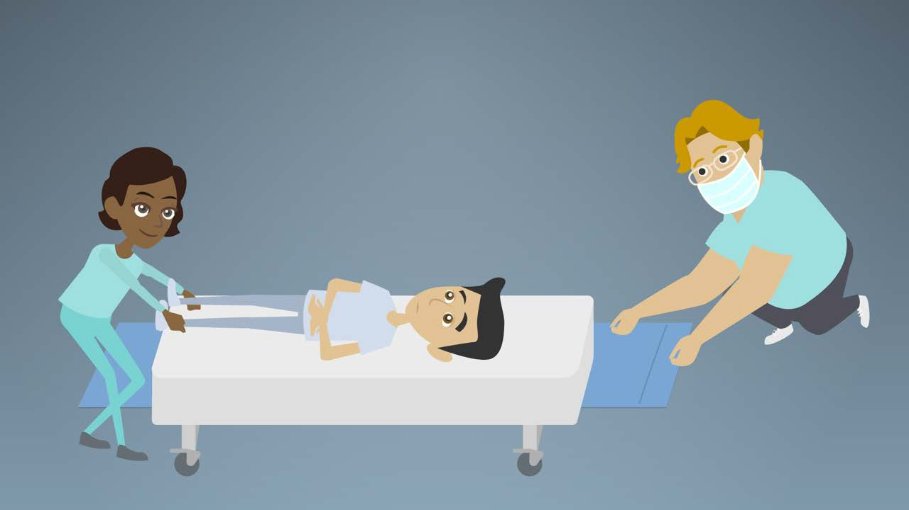  - One assistant pulls client/resident down towards foot of bed so that their head will clear bedside furniture during transfer to floor | 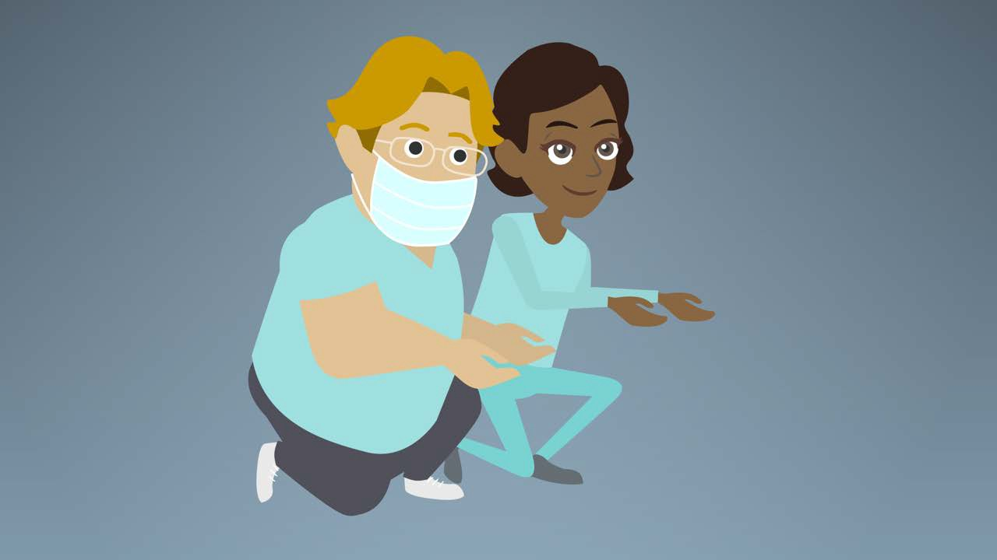  - Both assistants kneel beside bed with one knee on floor and other leg flexed to 90°  with the foot flat on the floor
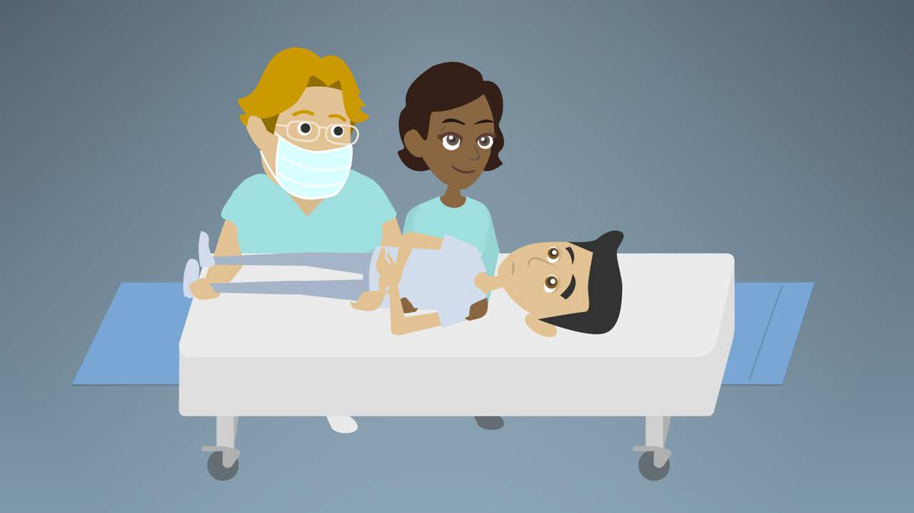  - Both assistants slide arms under client/resident, including top layer of bedding:  - Assistant at head slides one arm under shoulders and one arm under lower chest, grasping client’s/resident’s forearm to hold it close to their body  - Assistant at feet slides one arm  under hips and one under knees | 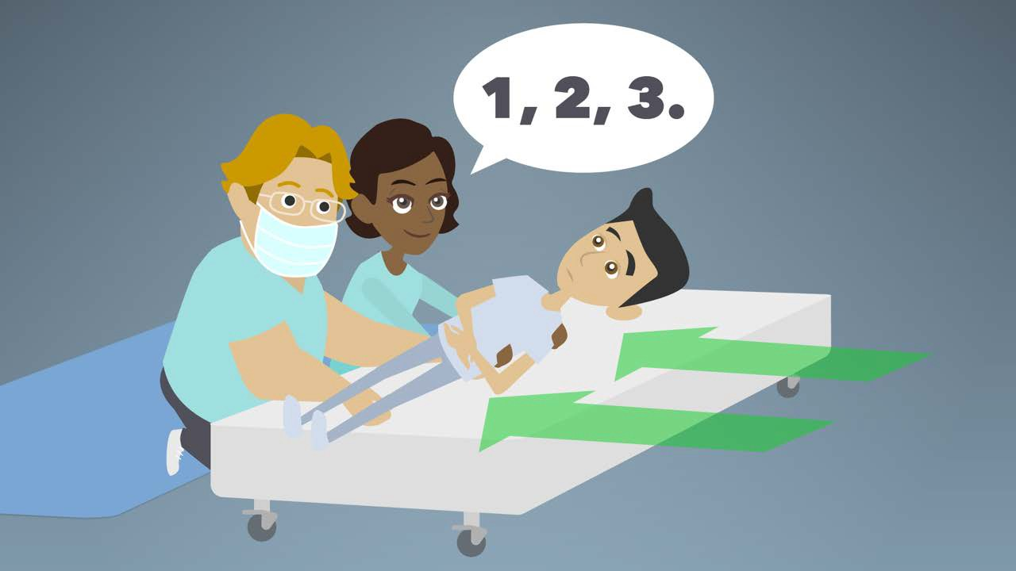  - One assistant organizes count (e.g. “1, 2, 3”)
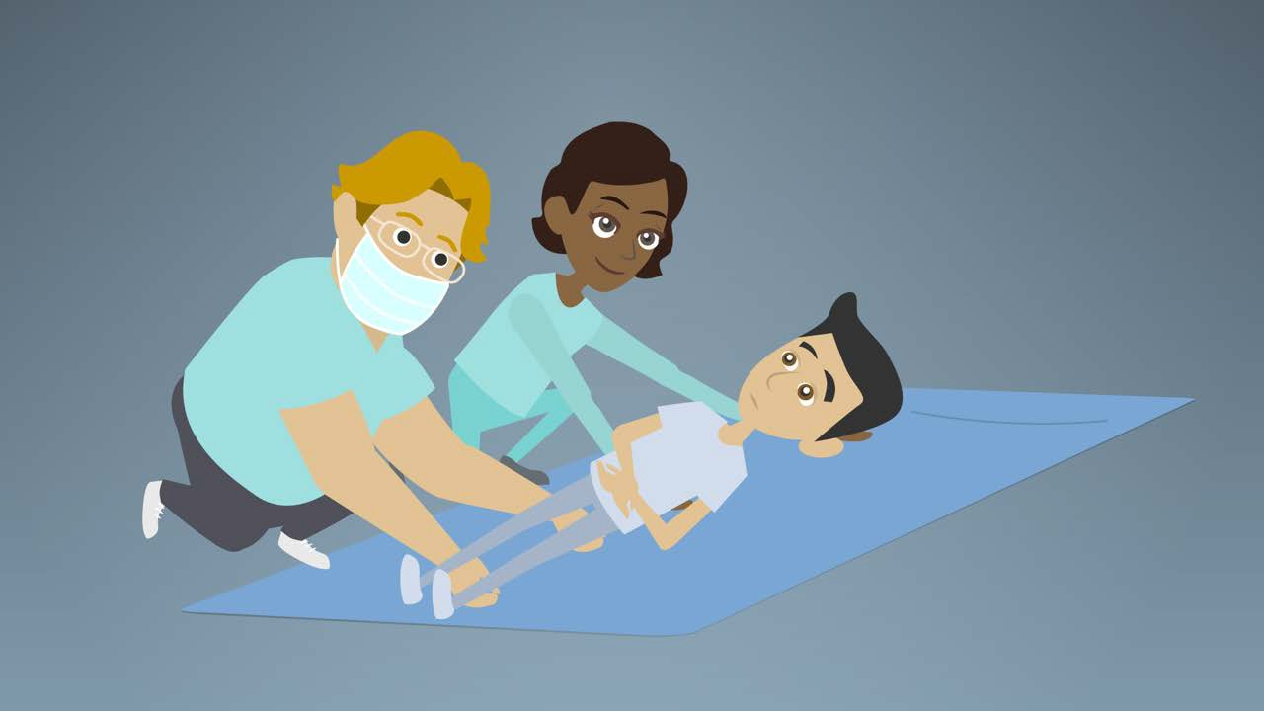  - Both assistants move client/resident to edge of bed and on to floor | 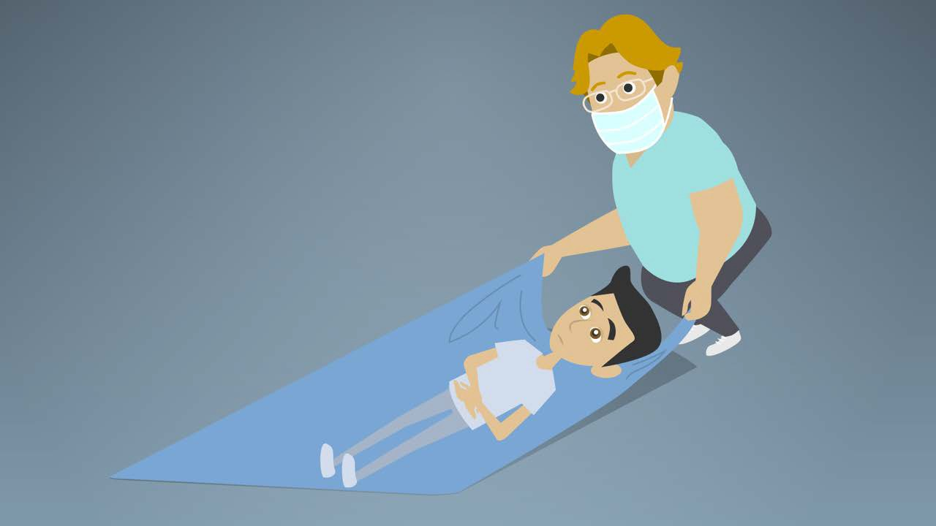  - Grasp blanket firmly and pull client/resident HEADFIRST into the safety zone

Single-person Sheet Drag

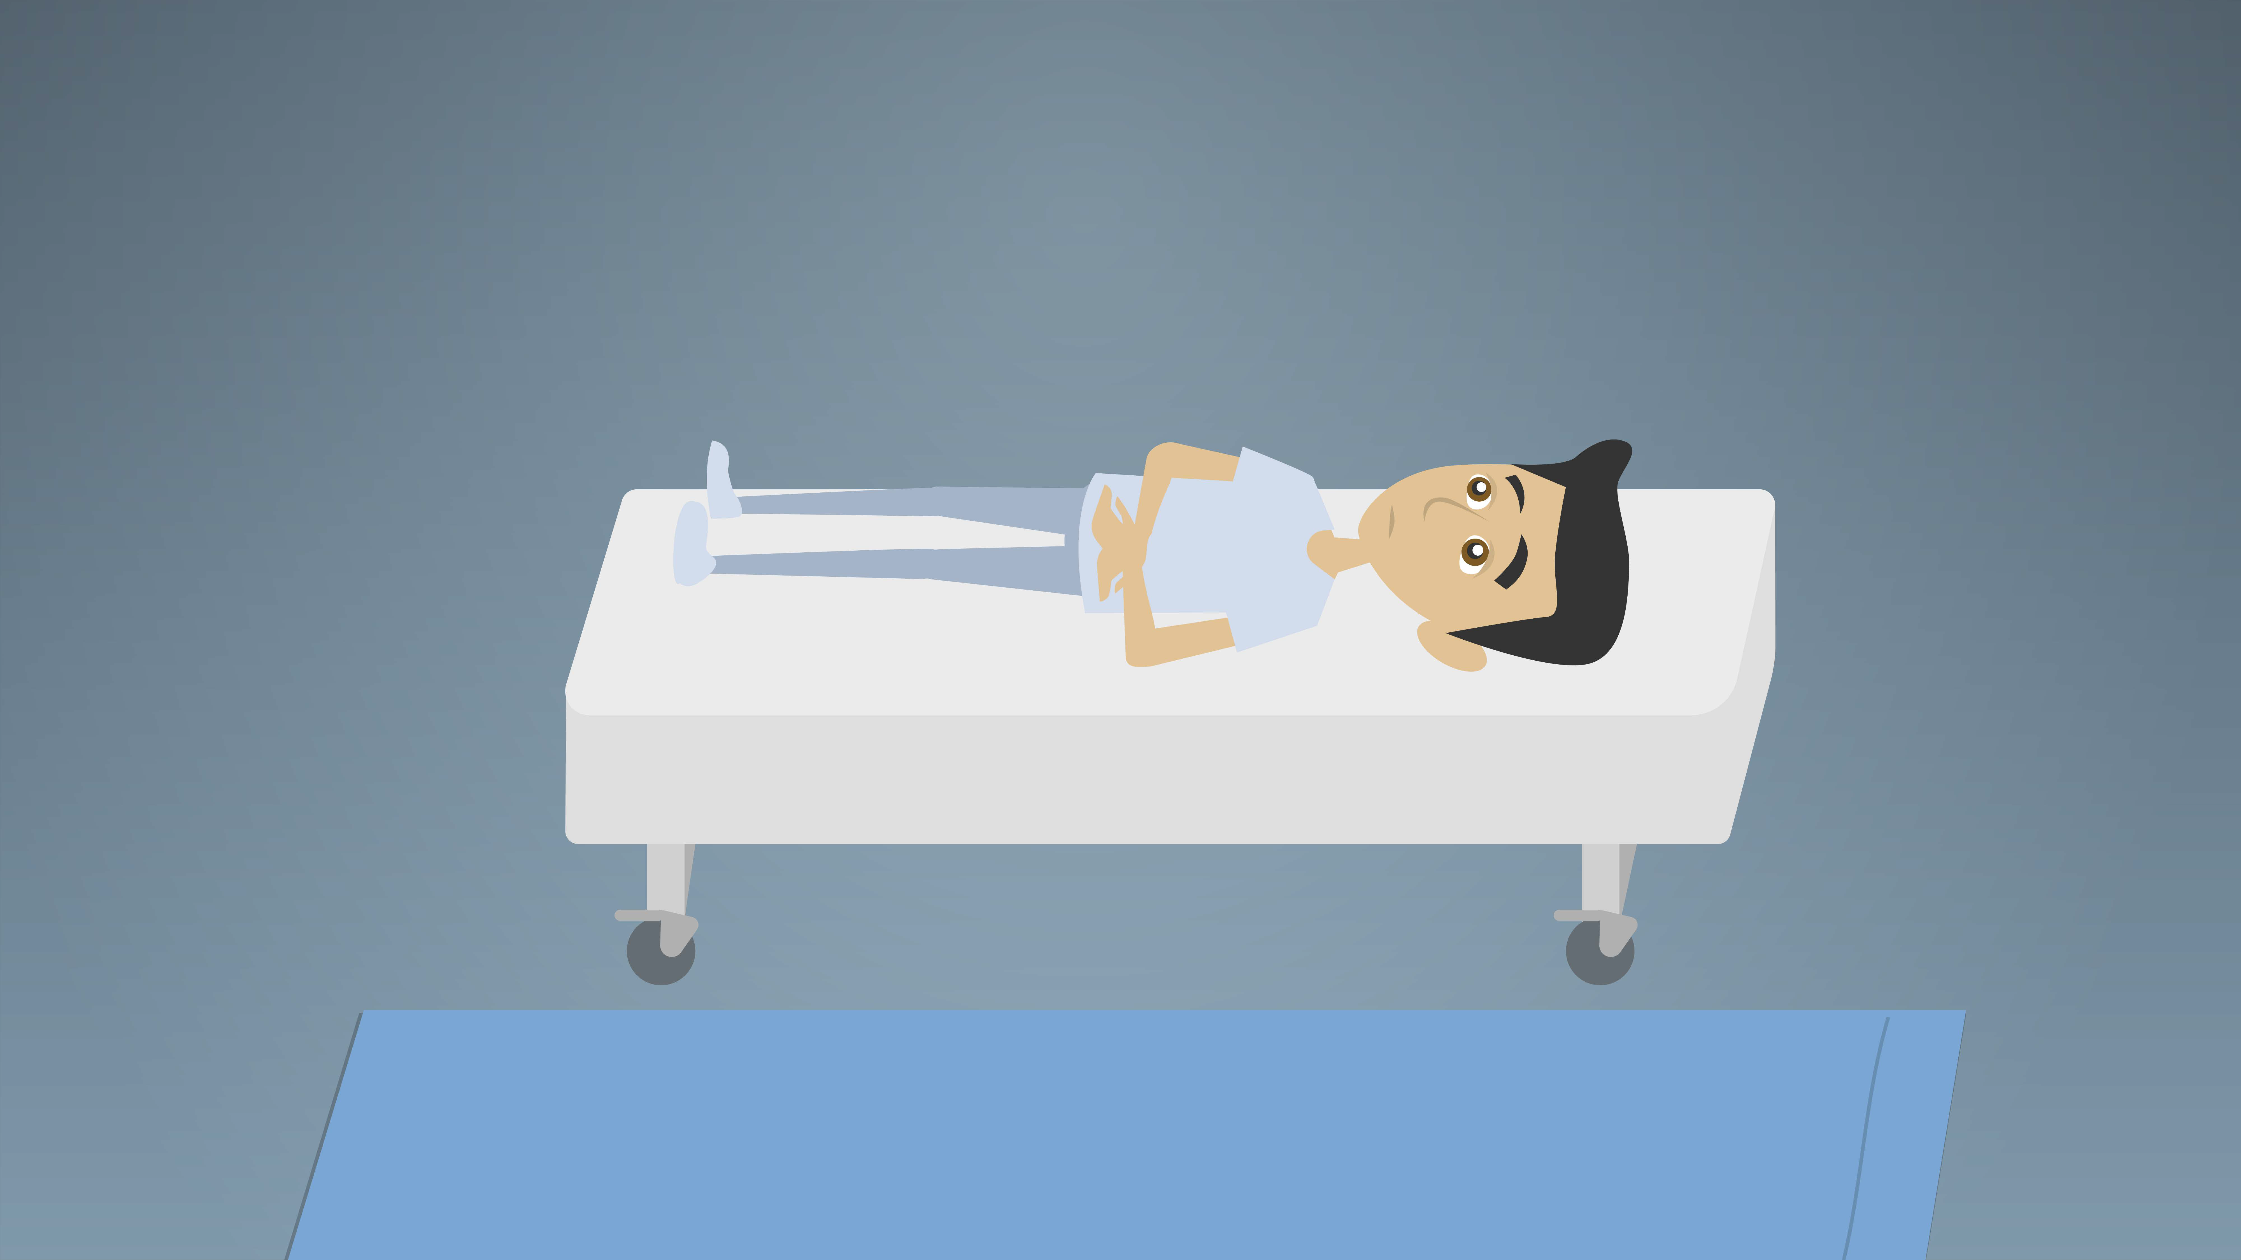  - Place blanket or sheet lengthwise on floor beside the bed | 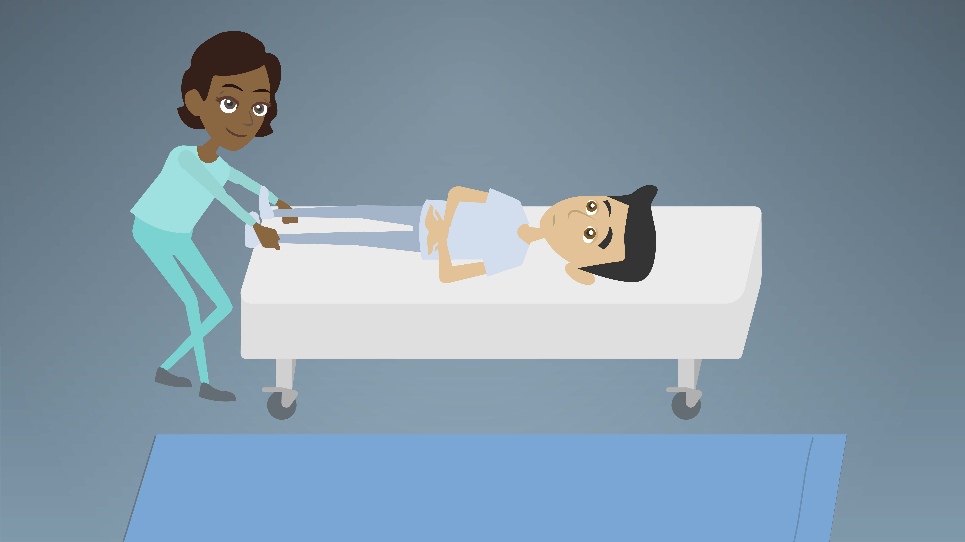  - Using client’s/resident’s feet, pull towards foot of bed so that head sill clear beside furniture during transfer to floor
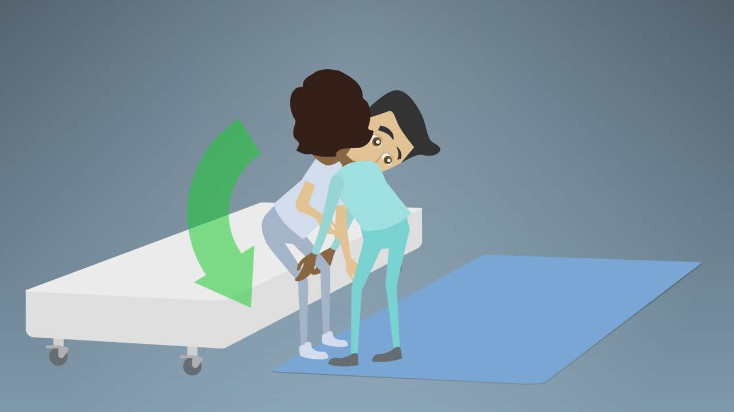  - Swing client’s/resident’s feet over edge of bed.  It does not matter if they tough the floor | 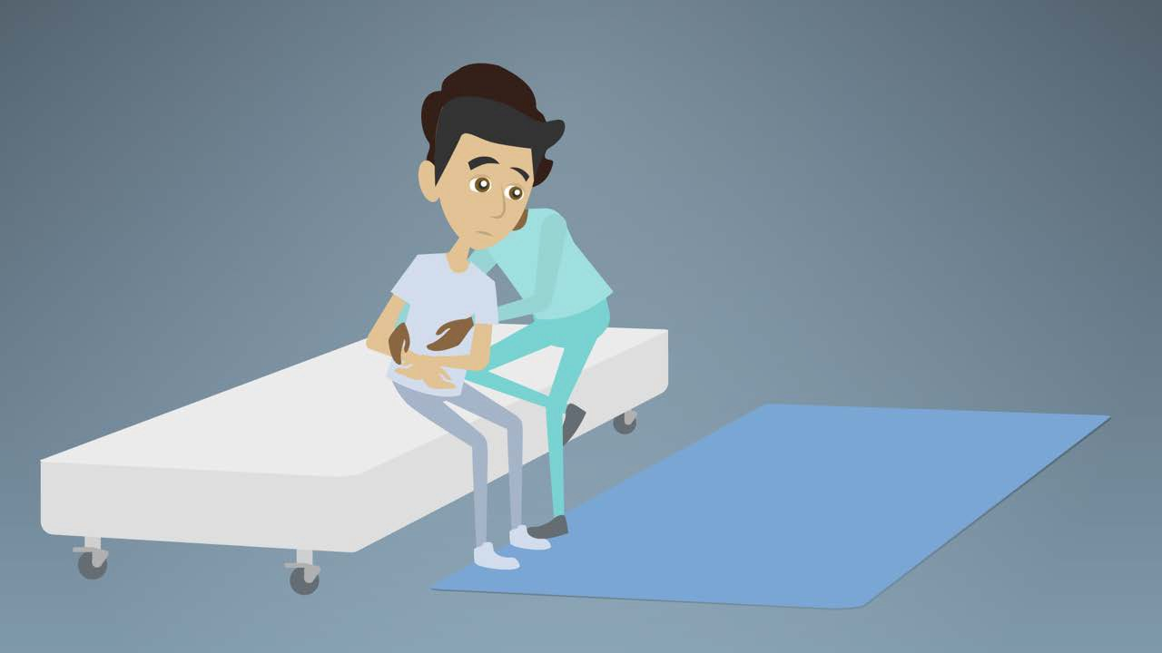  - Grasp client/resident from behind by sliding your arms under their axilla and grasping forearms in front of body
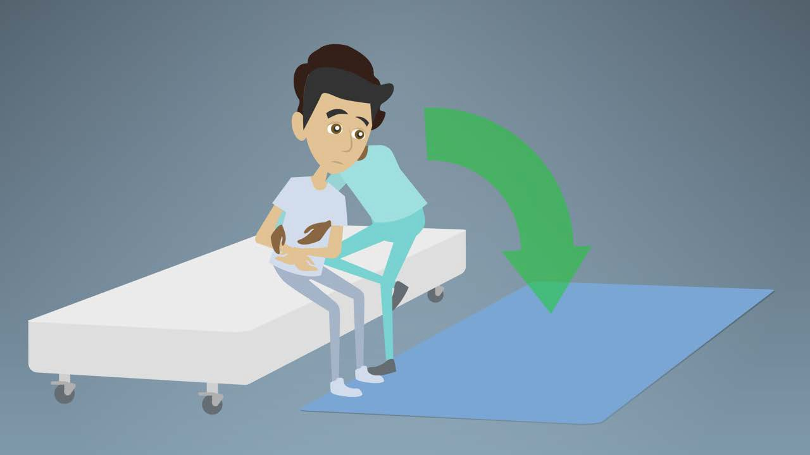  - Keeping one knee up on the bed to ensure a good pelvic tilt, lower client/resident over edge of bed and onto floor |   - Place both feet (bending knees and maintaining pelvic tilt) on floor behind client/resident, and protecting their head, lower them to a lying position, placing a pillow under head if possible
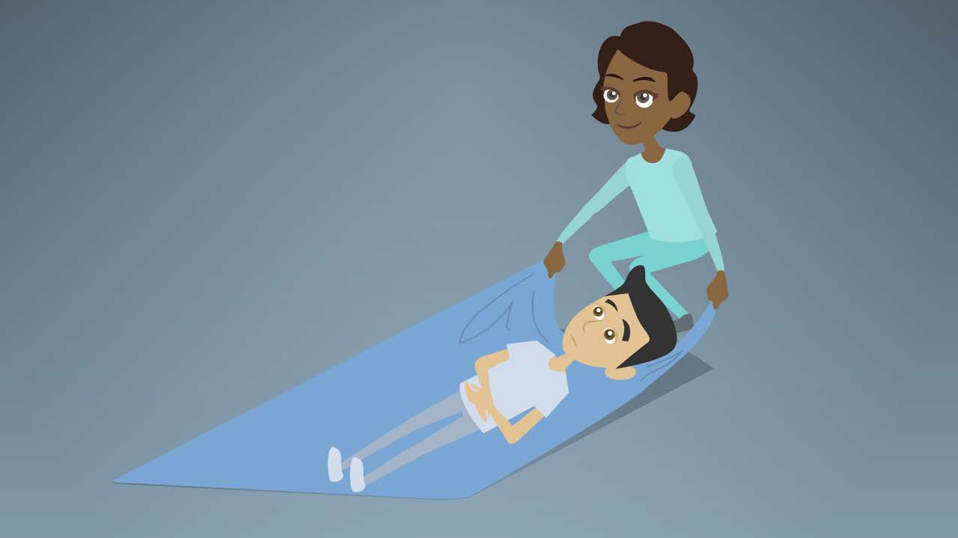
- Grasp blanket firmly and pull client/resident HEADFIRST into safety zone

