Overview
The Code Red Emergency Response or fire alarm is activated upon discovery or suspicion of the presence of fire. This facility responds to fire incidents using a shelter-in-place strategy.

As in all emergencies, consider your safety first.

If you discover or suspect the presence of fire or smoke, follow the R A C E procedure:

R | - Rescue or remove anyone in immediate danger and move them to a safe area
A | - Activate a fire alarm pull station  - Designate a runner/designate someone to announce overhead three times and state:  “Code Red [exact location – building, floor, room]”
C | - Contain the spread of smoke and fire by closing doors
E | - Extinguish the fire, if you feel safe to do so  - Evacuate if the area is unsafe by moving everyone through at least one set of fire doors  - Refer to Code Green: Evacuation
- Inform the Fire Department of the situation upon their arrival
- Inform responders of any special hazards in the area (for example: oxygen cylinders, flammable or toxic or corrosive chemicals, high magnetic fields, radioactive materials, etc.)

Response Procedures

Suspected or Confirmed Fire Emergency
- If a fire is suspected or confirmed on your unit:
  - If you discover smoke/fire, follow R A C E
  - If the area is unsafe, evacuate all occupants out of the hazard area to a safe area,
past a set of fire doors
  - Listen for overhead announcements
  - Take direction from overhead announcements, the fire department or designated personnel
  - Enact any department specific procedures

Fire Alarm Activation

If the fire alarm is activated within the building
- Assess your area and if you discover smoke or fire, follow R A C E
- If there is no evidence of fire or smoke, stay in your area unless directed otherwise
- Consider stopping all non-critical functions
- Prepare clients/residents for possible evacuation (refer to Code Green)
- Take direction from overhead announcements, the fire department, designated personnel or the [Manager/Director of Care/Designate]
- If requested, and as able, provide assistance to those areas that may be evacuating
- Stop all unnecessary travel, if you must move throughout the building, take stairs
  - DO NOT use elevators
- As appropriate:
  - Ensure fire doors are completely closed
  - Clear hallways of equipment
  - Enact any department specific procedures

If the source of the fire alarm is in your area
- Staff should immediately return to their unit via a safe route
- Investigate the source and cause of the alarm, check alarm panel for location
- Clear corridors of obstructions and be prepared to evacuate

All Clear
The “Code Red – All Clear” announcement indicates the facility may resume normal activities

Fire Extinguisher

Only use a fire extinguisher if:
- R A C E has been enacted
- You feel safe to do so
- You are familiar with how to use an extinguisher
- The fire appears manageable
- You have an exit route at your back

To operate a fire extinguisher, P A S S:
- Pull out the pin  Twist and pull to break the plastic seal, then remove the pin  - Aim nozzle at base of fire  Take the nozzle out of the clip, and aim it at the base of the fire  - Squeeze handles together  Discharge the powder by squeezing the handles together  - Sweep nozzle from side to side  Try to put a layer of powder over the item on fire | 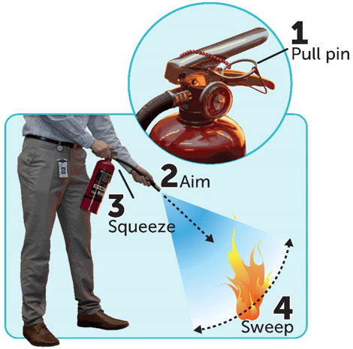  d

Unplug electrical equipment that is on fire if possible.

Once the fire is extinguished or the fire extinguisher is empty, place the extinguisher on the floor and evacuate the area, closing doors behind you as you leave.

Evacuation
- Any employee can remove someone from danger if there is an immediate threat to the health and safety of occupants
- Prioritize as follows (refer to Code Green):
  - 1 – Persons in immediate danger
  - 2 – Persons easiest to move
  - 3 – Persons most difficult to move
- The first choice for evacuation is to move horizontally to the other side of the fire doors,
on the same floor
- If unsafe to move horizontally, move vertically to a floor below using the nearest exit stairwell that is safe
- Persons on floors located below ground level may be required to move upward to the ground floor to exit building

Oxygen or Medical Gas Use

In the event of a fire in a room where oxygen or medical gas is in use, if safe:
- Turn off the gas at the source in the room
- If medical gas is in use near a fire and cannot be turned off at the source, use the area
shut-off valve
- Remove oxygen cylinders/concentrators from the room with the fire, if possible. If not safe to do so, report the presence of oxygen cylinders to the Fire Department on arrival

Clinical Staff working in areas supplied with medical gasses should be familiar with the local shut-off valves. Always consider the potential effects of shutting off oxygen to clients’/residents’ rooms that are also serviced by the shut-off valve.

Any decision to shut off medical gas must involve members of the client/resident care team.

Post incident actions
- Ensure proper documentation is completed, as applicable:
  - [Insert title of documentation that should be completed after a code red]
- Debrief and ensure psychosocial support is provided, as needed

Supports
- If you experience any type of distress from an incident, you are encouraged to seek incident debriefing or emotional support [insert information on who to speak with and any resources available]

