Overview
A Code Yellow is the coordinated response procedure required after it has been determined a client/resident with identified risk factors is missing and it cannot be confirmed they left the campus.

As in all emergencies, consider your safety first.

Process overview
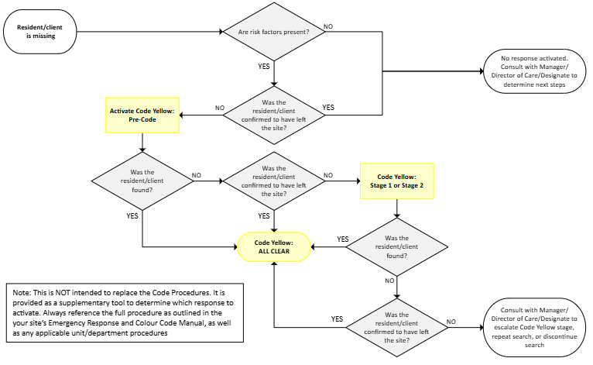

Definitions
A Code Yellow may be activated at any Stage, based on risk factors.
Code Yellow: Pre-Code | - Outlines steps taken prior to initiating a full Code Yellow activation, including a preliminary search involving unit staff.
Code Yellow: Stage 1 | - Outlines steps required to complete a more comprehensive search of the campus. Steps include raising the awareness level of all staff via announcements and email description.
Code Yellow: Stage 2 | - Upon authorization of the [Manager/Director of Care/Designate], outlines steps required to complete an intensive search of the entire campus, including locked areas, service/support areas and grounds.
Risk Factors | - Risk factors are attributes, characteristics or circumstances surrounding the missing client/resident and are utilized to determine the level of activation required.  Key Risks Examples  Cognitive Impairment - Unable to find their way back to the unit/residence  Psychiatric Risk Factors - Experiences hallucinations, impulsive behavior, or non-sensical speech  Age, Frailty, Mobility - At risk for falls or cold temperatures  Immediate medical concerns - Need important medication or treatment  Likely to harm self or others - Suicidal or threatening to another person  Other considerations - Risk of overdose - Recorded incident(s) from previous admissions - Social risk factors - Certified under the Mental Health Act - Treated under the Health Care (Consent) and Care Facility (Admission) Act  With no known risk factors, Emergency Response processes are not applicable. It is deemed that a client/resident with no risk factors has made an informed choice to leave the care space.

Response Procedures

Pre-Code - Activated by [Nurse in-Charge/Designate]

Staff Member
- When a client/resident is first noticed missing:
  - Notify [Nurse in-Charge/Designate]

[Nurse-in Charge/Designate]
- Notify unit staff of the missing client/resident
  - Provide a description of the missing client/resident and any safety concerns
  - Ensure the unit, common areas, and surrounding areas are searched by staff
- Notify [Manager/Director of Care/Designate]

If the client/resident is confirmed to have left the site:
- Discontinue the search and stand down response efforts
- Consult with [Manager/Director of Care/Designate] to determine next steps

Pre-Code Outcomes:

[Nurse in-Charge/Designate]
If found:
- Document incident
If not found:
- Review the risk factors and, in consultation with [Manager/Director of Care/Designate], determine if a Code Yellow: Stage 1 or Code Yellow: Stage 2 activation is required
- If the client/resident is treated under the Health Care (Consent) and Care Facility (Admission) Act, contact Most Responsible Physician for direction
  - Certification under the Mental Health Act is required to bring a client/resident back to the facility
- If the client/resident is Involuntary or Certified, notify Police
  - Complete a Warrant for Apprehension under the Mental Health Act
If the client/resident is confirmed to have left the site:
- Discontinue the search and stand down response efforts
- Consult with [Manager/Director of Care/Designate] to determine next steps

Code Yellow: Stage 1 - Activated by [Nurse in-Charge/Designate]
A Code Yellow: Stage 1 may be activated after risk factors have been reviewed and it has been determined that a comprehensive search is required.

[Nurse in-Charge/Designate]
- Notify all staff of the missing client/resident
  - Complete/designate someone to complete the Code Yellow Email Notification template and forward to site distribution list
  - Designate a runner/designate someone to announce overhead three times:
    - “Code Yellow [age, descriptor(s), and exact location]
- Notify:
  - [Manager/Director of Care/Designate]
  - [Insert departments/agencies/organizations to be notified and consider if family or physicians notifications should be made]
If the client/resident is confirmed to have left the site:
- Discontinue the search and stand down response efforts
- Consult with [Manager/Director of Care/Designate] to determine next steps

All Staff
- Upon hearing Code Yellow: Stage 1 announcement, refer to the email description of the missing client/resident
- Immediately search your unit and surrounding areas
- Report any findings to your [Nurse in-Charge/Designate]

Code Yellow: Stage 1 – Outcomes

[Nurse in-Charge/Designate]
If found:
- Notify all staff of the “Code Yellow – All Clear” via overhead announcement/designate a runner
  - Forward/designate someone to forward the “Code Yellow – All Clear” email to site distribution list
- Notify:
  - [Manager/Director of Care/Designate]
  - [Insert departments/agencies/organizations to be notified and consider if family and physician notifications should be made]
- Document the incident

If not found:
- Review the risk factors and in consultation with the [Manager/Director of Care/Designate], determine if ‘All Clear’ is appropriate or if a Code Yellow: Stage 2 is required
- If the client/resident is treated under the Health Care (Consent) and Care Facility (Admission) Act, contact Most Responsible Physician for direction
  - Certification under the Mental Health Act is required to bring a client/resident back to the facility
- If the client/resident is Involuntary or Certified, notify Police
  - Complete a Warrant for Apprehension under the Mental Health Act

Code Yellow: Stage 1 – Outcomes (continued)
If the client/resident is confirmed to have left the site and/or an intensive search is NOT appropriate:
- Discontinue the search and stand down response efforts
- Consult with [Manager/Director of Care/Designate] to determine next steps
- Notify all staff of the “Code Yellow – All Clear” via overhead announcement/designate a runner
  - Forward/designate someone to forward the “Code Yellow – All Clear” email to site distribution list
- Notify:
  - [Manager/Director of Care/Designate]
  - [Insert departments/agencies/organizations to be notified and consider if family and physician notifications should be made]
- Document the incident

If an intensive search is necessary, contact the [Manager/Director of Care/Designate] for authorization to proceed to a Code Yellow: Stage 2

Code Yellow: Stage 2 - Authorized by [Manager/Director of Care/Designate]
A Code Yellow: Stage 2 may be activated after risk factors have been reviewed and it has been determined that an intensive search and Emergency Operation Centre (EOC) activation is required.

[Manager/Director of Care/Designate]
- Assume or delegate role of EOC Director
- Ensure the EOC is activated
- Notify any additional leadership, as necessary

If the client/resident is confirmed to have left the site:
- Discontinue the search and stand down response efforts
- Consult with [Nurse in-Charge/Designate] and additional leadership, as necessary, to determine next steps

EOC Director
The EOC Director is responsible for coordinating an intensive search of the entire campus.
- Obtain the Code Yellow Kit
- Review EOC Director Job Action Sheet located in Code Yellow Kit
- Appoint a Search Coordinator and other EOC Functions, as needed
- Notify all staff of Code Yellow Stage 2 EOC activation
  - Complete the Code Yellow Email Notification Template
    - If client/resident is admitted under Do Not Acknowledge (DNA) criteria, do not include their name in the email
  - Announce via overhead announcement or designate a runner:
    - “All available staff report to the EOC [location]”
- Provide status updates to additional leadership, as necessary

Code Yellow: Stage 2 – EOC Director (continued)
- Notify:
  - [Insert departments/agencies/organizations to be notified and consider if family and physician notifications should be made]
- Consider contacting taxi, bus companies and other local establishments

Search Coordinator
- Review Search Coordinator Job Action Sheet located in the Code Yellow Kit
- Establish two-person search teams
- Distribute search maps to available teams; ensure all areas are assigned
- Brief search teams on:
  - Missing client/resident description
  - Client/resident risk factors
  - Current situation
  - Search methods (for example: place tape on doors of searched rooms)
  - Documentation requirements (for example: initial searched areas, identification of locked spaces, searcher name, etc.)
- Record personnel assigned to search teams and their assigned areas
- Receive and record results
- Provide status updates to EOC Director

Code Yellow: Stage 2 (continued)

Search Teams
- Receive instructions from the Search Coordinator or EOC Director
- Retrieve supplies from the Code Yellow Kit
- Review Search Team responsibilities and map assignment
- Conduct Search
  - Place your initials on the floor plan as each area is searched
- Notify the EOC if you locate the missing client/resident
- Complete and return all documentation to the EOC and await further instructions

Nurse In-Charge/Leads/Designates
- Identify available staff in the units to assist in the search and send them to the EOC to receive direction

Code Yellow: Stage 2 – Outcomes

EOC Director
If found:
- Notify all staff of the “Code Yellow – All Clear” via overhead announcement/designate a runner
  - Forward/designate someone to forward the “Code Yellow – All Clear” email to site distribution list
- Notify:
  - [Manager/Director of Care/Designate]
  - [All previously contacted parties]
- Document the incident
- Request site administration replenish the Code Yellow Kit and return to original location
- Retain all incident documentation, for potential legal review including search logs
If not found:
- Based on a thorough evaluation and in consultation with the
Nurse in-Charge/Upper Leadership/Designate:
  - Repeat the search or consider taking steps to discontinue the search on site
- If the client/resident is treated under the Health Care (Consent) and Care Facility (Admission) Act, contact Most Responsible Physician for direction
  - Certification under the Mental Health Act is required to bring a client/resident back to the facility
- If the client/resident is Involuntary or Certified, notify Police
  - Complete a Warrant for Apprehension under the Mental Health Act
- Consider further communication to all staff
If the search is discontinued on site:
- Notify all staff of the “Code Yellow – All Clear” via overhead announcement/designate a runner
  - Forward/designate someone to forward the “Code Yellow – All Clear” email to site distribution list
- Document the incident
- Request site administration replenish the Code Yellow Kit and return to original location
- Retain all incident documentation, for potential legal review including search logs
- Consider further communication to all staff

post incident actions
- Ensure proper documentation is completed, as applicable:
  - [Insert title of documentation that should be completed after a Code Yellow]
- Debrief and ensure psychosocial support is provided, as needed

supports
- If you experience any type of distress from an incident, you are encouraged to seek incident debriefing or emotional support [insert information on who to speak with and any resources available]

PLEASE CHECK WORK AREA FOR THE FOLLOWING CLIENT/RESIDENT
Site:
Unit:
Number to call if found:
Place/Time last seen:
Code Yellow stage:
Client/Resident Description
Name:
(For cases of ‘Do Not Acknowledge’ (DNA) do not insert name)
Race:
Gender:
Age:
Height:
Weight/Build:
Hair Colour/Style:
Eye Colour/Glasses:
Scars/Marks/Tattoos:
Coat/Shirt Colour/Style:
Pants Colour/Style:
Gown-Pyjamas:
Hat Colour/Style:
Shoes:
Risk/Concerns:
Additional Information/Picture:

