SEARCH MAP – [Site] |  |  | [Floor] | Map x of x
Date: M/D/Y | Time your search started: (24) | Time search ended: (24) |   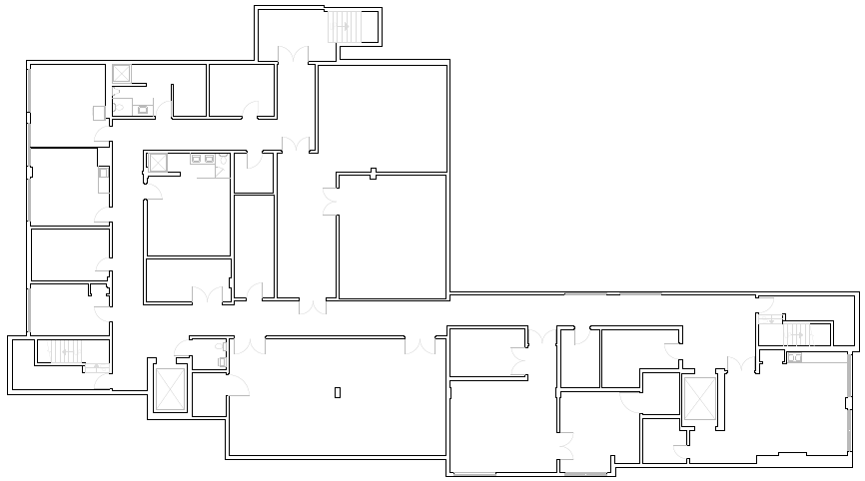
Searcher Name(s): (print)
Search Instructions
- Go to assigned search area, bring map(s) and search supplies with you
- Search all rooms and areas, including offices, care areas, bathrooms, stairwells, closets, cupboards, elevators, and locked areas
- As you search, place your initial in the area/room on map. Note any locked rooms that you did not search with an “X” on map. Advise Search Recorder upon your return to EOC which spaces you did not search.
- Upon completion of your search, return to the EOC and await further instructions
- If you hear an “All Clear”, return to EOC
- If you find the client/resident, call the EOC, Security, or request medical assistance as necessary. If you feel unsafe, move to a safe place and then call the EOC. Do not place yourself in an unsafe situation.
SITE MAP

Searcher 1 Signature___________________ Searcher 2 Signature_____________________ IF CLIENT/RESIDENT FOUND, NOTIFY EOC DIRECTOR

